# Experiment No: 8

**Aim:**

Familiarisation of Linux Commands.

# CO2:

Perform System Administration tasks.

# Procedure:

**1)**ip addr-To get the ip address

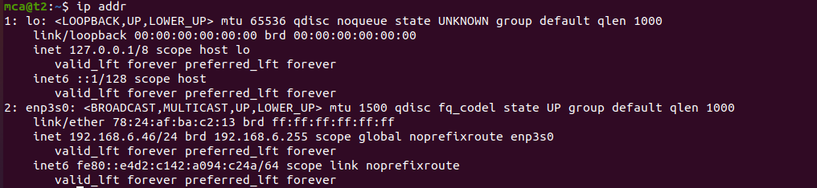

**2)**sudo apt-get install openssh-server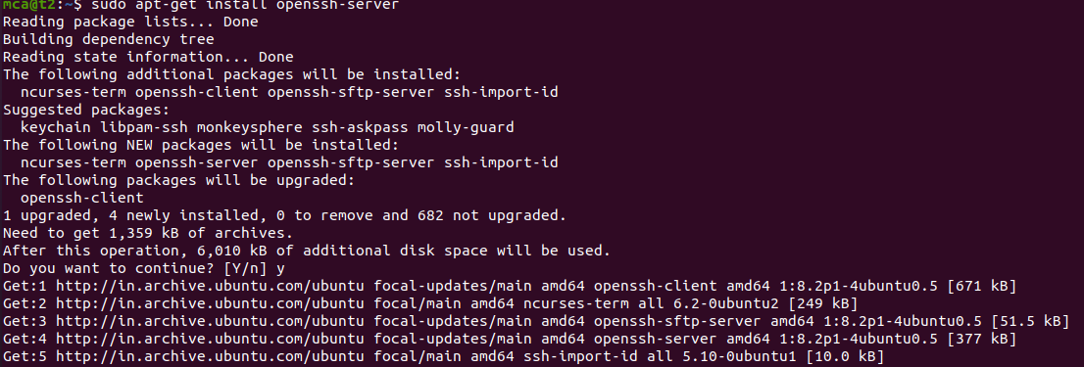

**3)**sudo ufw allow [port no] - Allow access to the port

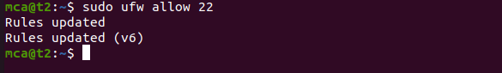

**4)** ssh mca@192.168.6.29 ie. ssh [username]@[neighbour ip address]

sshh stands for secure shell protocol used tyo securely connnect your or system .ssh is secures in sense it transfers data in encrypted form between host and client.

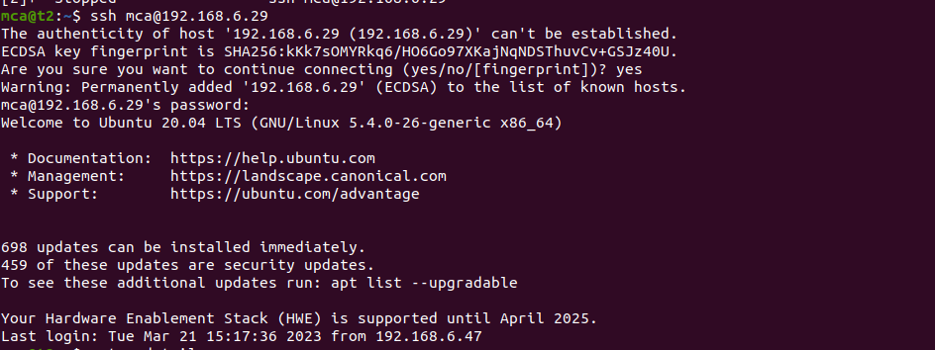

**5**)ssh-keygen -

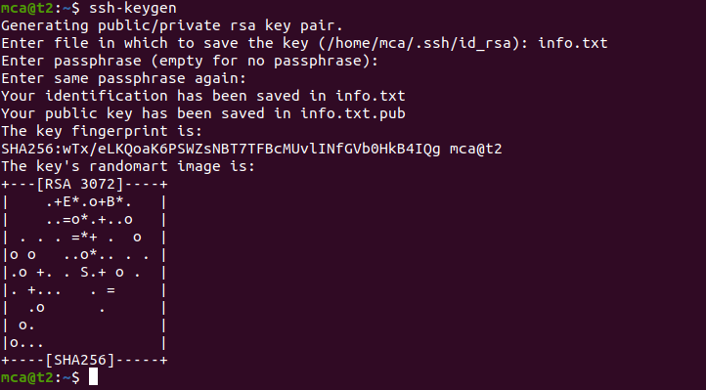

**6)**

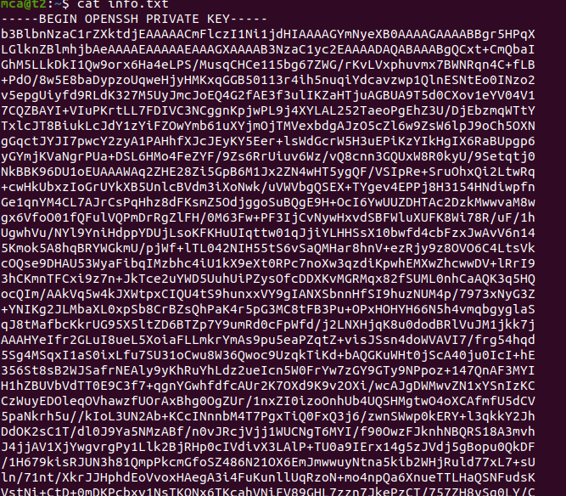

**7)** ps

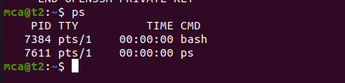

**8)**ps -u mca- Display the users currently running process information

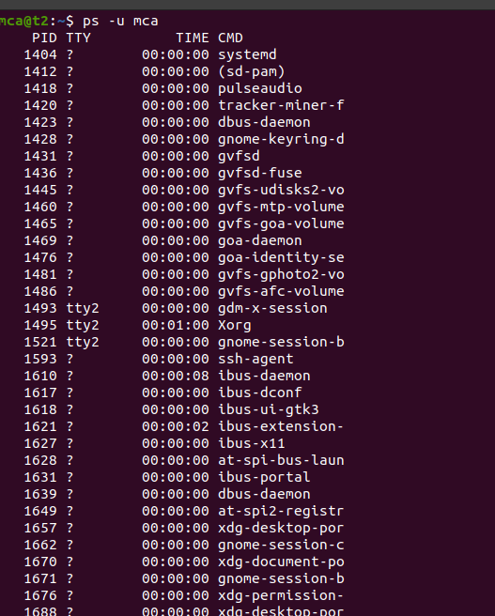

**9**)ps -C firefox-

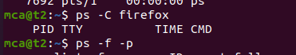

**10**)ps -f -p [process id number]

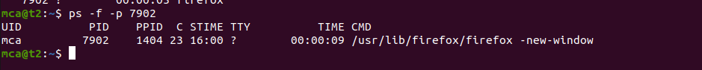

# Result:

The program was executed and the result was successfully obtained. Thus CO2 was obtained.